INTRODUCTION

Salesforce Customer 360 is our entire portfolio of products and services. It’s an integrated customer relationship management (CRM) platform that helps companies transform their businesses by uniting their marketing, sales, commerce, service, and IT teams with a single, shared customer view.

With Customer 360, the world’s CRM you entire company can work on one trusted platform with best in class apps that are easy to use and free to learn, united by a single, shared view of your customer data. That increases collaboration and alignment among all your teams, which leads to lower

PURPOSE

With customer 360, businesses can segment their customers as based on a variety of attributes, such as purchase history, demographics, and behavior. This segmentation enables targeted marketing and personalized engagement that can improve customer loyalty and retention.

It creates a 360-degree view of each customer, by consolidating data from multiple systems. This unified customer profile provides a holistic understanding of customer interactions and allows for more personalized engagement. This ensures that businesses can handle customer data with confidence and integrity.

EMPATHY MAP

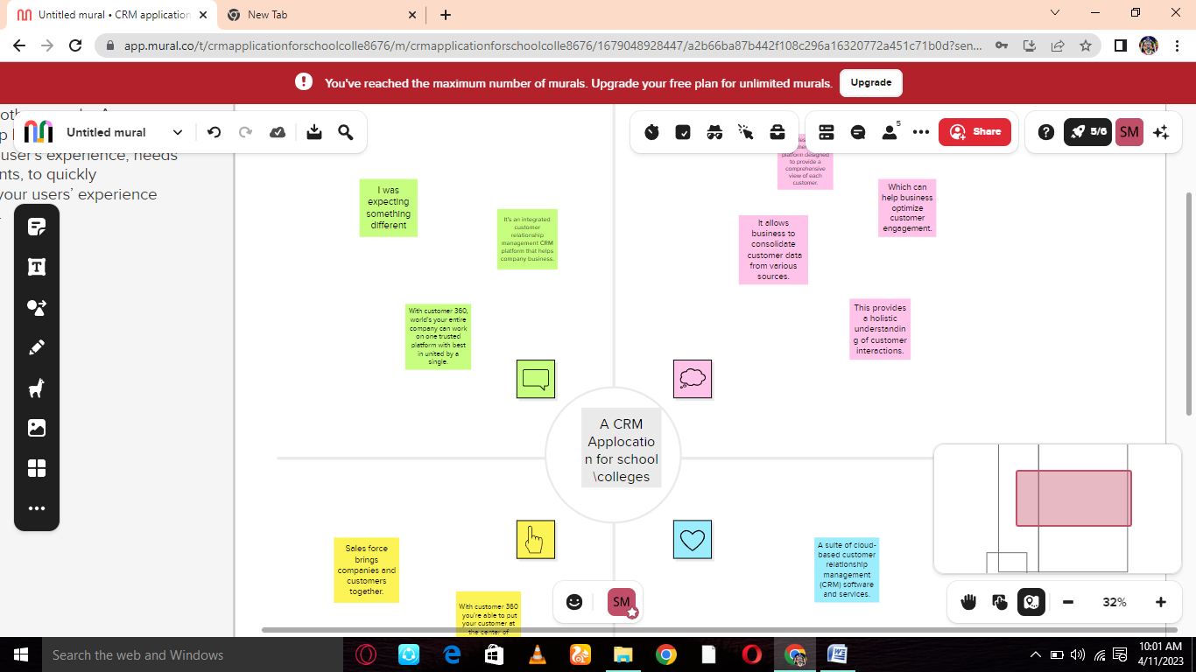

IDEATION & BRAINSTORNING MAP

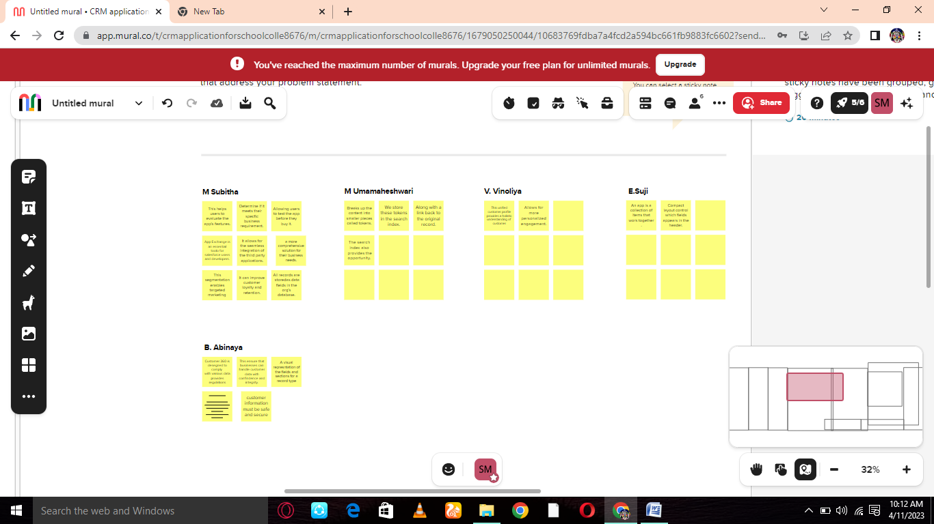

RESULT

Data Model

|  |  |
| --- | --- |
| Object Name | Fields in the Object |
| Obj1 | |  | | --- | |  |  |  |  |  |  |  |  |  | | --- | --- | --- | --- | --- | --- | --- | | |  |  | | --- | --- | | Field label | Data type | | Address | Text Area | | District | Text Area | | |
| Obj2 | |  |  | | --- | --- | | Field lable | Data type | | Result | Picklist | | Class | Picklist | |

Activity&Screenshot

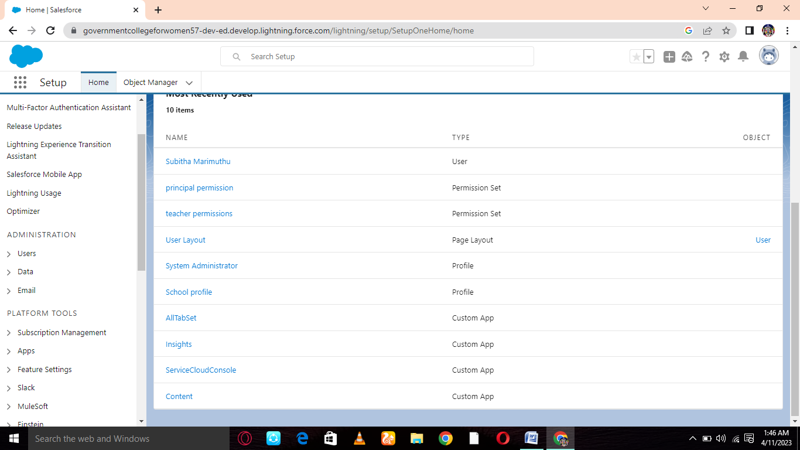

ADVANTAGES AND DISADVANTAGES

Every business is planned, established and run on based of its customer. Customer are like the blood of every business, without which business organs cannot function.

DISADVANTAGES

None

APPLICATIONS

Wheather its marketing, customer service, notification, done manually semi even fully automated with our messager communication platform.

CONCULSION

The CRM and the mobile app very easy and simple to use for any kind of user event without any kind of computer knowledge. All flexible customization are available in the system.

FUTURE SCOPE

Manage all kind of automation including allocate of leads to sales team manage them to be in touch your leads prospect are customer in simplified manner.